**Child and Adolescent Practice Scale (CAPS-CBT)**

1. **Children and Young Person’s Improving Access to Psychological Therapies**

The Children and Young Person’s IAPT was launched in October 2011 with the core aims of transforming CAMHS by:

* Developing child/young person focused services
* Routinely using outcome measures to monitor progress and assess change
* Encouraging reflective practice through the development of supervision
* Training in evidenced based approaches (CBT and Parenting)

The first wave of funding has been agreed to provide training for therapists, supervisors and managers in order to secure these objectives. HEIs and CAMHS providers have joined together to form training collaboratives so that academic learning and development can be firmly embedded within clinical services.

A working group commissioned by the DH produced a curriculum detailing the content of the IAPT training. Evidence based treatment programmes were examined, core elements identified and the competencies required to deliver these specified.

1. **CAMHS Competencies**

An evidence based competency framework for CAMHS was commissioned by NES Scotland and developed in collaboration with UCL (Roth, Calder & Pilling, 2011). This details the knowledge and skills underpinning the clinical activities carried out by a CAMHS service and provides a framework which details

* core competencies for working with children and young people,
* generic therapeutic competencies
* assessment and formulation skills
* specific therapeutic competencies
* meta competencies

1. **CBT competencies**

The above framework provides an overview of general CAMHS competencies but is not specific to the practice of CBT. Assessing CBT competence in adult services has relied upon the revised Cognitive Therapy Scale (Blackburn et al 2001). The scale assesses competence in each of 12 areas on a 7 point Likert scale. Whilst widely used with adults the scale does not capture many of the competencies required to practice CBT effectively with this younger age group.

* Important systemic influences in the onset and maintenance of the child’s problems need to be acknowledged and the role of the carers/family in CBT considered.
* The child’s cognitive, emotional, linguistic and reasoning ability are developing and CBT needs to be appropriately adapted to be consistent with the child’s abilities
* Creative non-verbal methods may be required to convey the concepts of CBT to children in a clear and understandable ways
* The process of undertaking CBT with children and their carers needs more specification.

1. **A framework** The diagram below attempts to summarise the core competencies required to effectively practice CBT within the CYP IAPT.

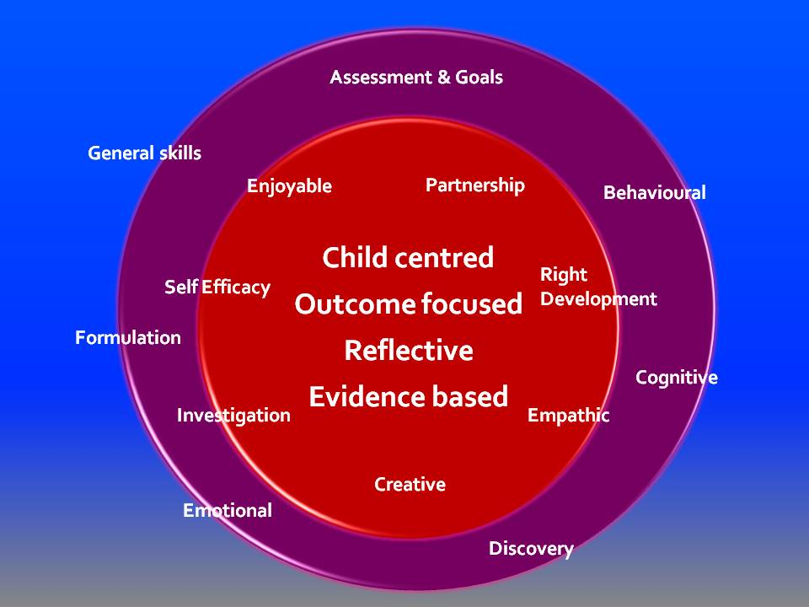**Process (PRECISE)**

The middle segment defines the

process of CBT

P - Partnership working

R - Right developmental level

E – Empathic

C – Creative

I – Investigative

S – Self efficacy

E - Enjoyable

**Specific Skills (A, B, Cs)**

The outer segment defines the

specific techniques

A – Assessment and goals

B – Behavioural techniques

C – Cognitive techniques

D – Discovery experiments

E – Emotional techniques

F – Formulation

G – General skills

1. **Child and Adolescent Practice Scale for CBT (CAPS –CBT)**

**The CBT process and technique skills have been defined in the CAPS-CBT where examples are provided of appropriate evidence in each area.**

**Process competencies are assessed from the perspective of the parent/carer, children (under 11) and young people (11-18). It is expected that trainees will demonstrate competence with parent a child and a young person. Technique skills are assessed in relation to use with a child and a young person.**

**The scale should be completed by the trainee and reviewed with their supervisor on three occasions, at the start, mid way and end of training. This will highlight particular strengths and training needs. CAPS-CBT will also be used to assess video and audio tapes of clinical sessions.**

**Rating the scale**

The seven point scale (i.e. a 0-6 Likert scale) extends from (0) where the trainee does not believe they currently meet competence to (6) where they believe they are currently expert in that particular competence. A score of 6 (Expert) should only be used if the competence has been demonstrated in the face of significant difficulties. For example, partnership working may be rated as expert if the family/child are very hostile or critical and yet the clinician was able to maintain a collaborative relationship). It is expected that in most sessions significant difficulties will not be present and so maximum ratings of competence will be 5 (Proficient).

Mark each competence using whole and half numbers to indicate the level to which each competence has been demonstrated

The process of rating involves two stages:

1. Decide whether or not the person is competent in each area. If judged competent ratings will be in the range 3-6; not competent in the range 0-2.
2. Look through each sample description in the range and decide which point best describes the trainees performance.
3. Pass/Fail

The overall percentage score is determined by totalling the scores on each of the 14 competencies and multiplying by 1.19.

A score of less than 2 on any item is a fail

**Competence Levels**

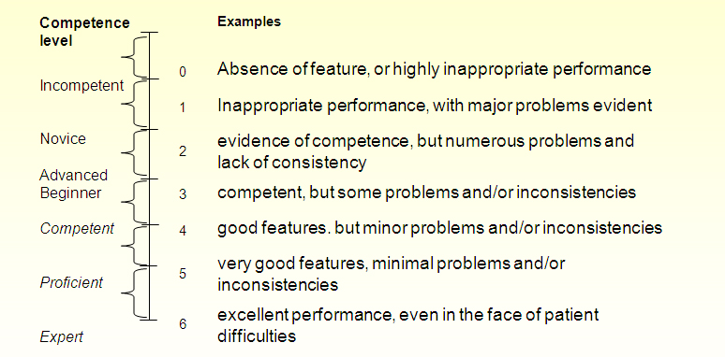

|  |
| --- |
|  |

* The present scale has incorporated the Dreyfus system (Dreyfus, 1989) for denoting competence. Please note that the top marks (i.e. near the 'expert' end of the continuum) are reserved for those practitioners demonstrating highly effective skills, particularly in the face of difficulties.

When rating each item, you must consider whether you should be regarded as competent in that particular area.

**Reference**

Dreyfus, H. L. (1989). The Dreyfus model of skill acquisition. In J. Burke (ed.) Competency based education and training. London: Falmer Press.

**Process**

|  |  |
| --- | --- |
| **Partnership working - collaboration & learning together** | **Competence Level Examples**  **(score according to features not examples)** |
| The therapist establishes a collaborative and respectful partnership with the child/young person (and as appropriate their parents/carers) in which they are actively engaged in working towards a set of joint goals and targets**.**  This may be evidenced by the therapist:   * Encouraging & inviting the child/young person’s participation in discussions, option appraisal, solution generation & decision making * Eliciting the child/young person’s and parents/carers understanding and views * Involving the child/young person and parent/carer in goal and target setting, intervention planning and agreeing home activities and experiments * Encouraging the child/young person to provide open and honest feedback about therapy sessions | Incompetent 0 Didactic therapist style, collaboration not encouraged, child views  not sought or ignored  Incompetent 1 Therapist is too controlling, domineering or passive and a  partnership is not established  Novice 2 Occasional attempts at collaboration but domineering or passive  style of therapist limits  the establishment of a collaborative partnership  Advanced 3 Collaborative partnership evident but **major** problems  beginner e.g. not enough opportunities for child or carer participation  Competent 4 Collaborative partnership established but **not consistent** or  some **minor** problems fully involving child or carers.  Proficient 5 Good collaborative partnership established with all involved  throughout most of the session. Minimal problems  Expert 6 Highly effective and respectful partnership even in the face of  difficulties |
| **Right developmental level - pitch, methods, family involvement** | **Competence Level Examples**  **(score according to features not examples)** |
| **The therapist engages with the child/young person and family in a way, level and manner that is consistent with their developmental level and understanding**  This may be evidenced by the therapist:   * Using simple, clear, jargon free language that is respectful and not patronising * Ensuring an optimal balance between cognitive and behavioural techniques * Conducting sessions at an appropriate pace * Appropriately using a variety of verbal (direct and indirect approaches) and non-verbal techniques * Appropriately involving parents/ carers in treatment sessions. | Incompetent 0 Therapist shows no recognition/awareness of the developmental  stage of the child/family  Incompetent 1 Therapist adopts a “standardised approach” that is not pitched at  the right level  Novice 2 Occasional recognition of developmental issues but the majority  of the intervention is not modified or consistent with the  child/family level of understanding  Advanced 3 Demonstrates some awareness of developmental  beginner issues but **major** problems e.g. in ensuring that communication  is pitched at the child/family’s level of understanding    Competent 4 Developmental issues recognised and intervention suitably  tailored but **not consistent** or some **minor** problems evident  Proficient 5 Intervention appropriately pitched and tailored to the  developmental stage /understanding of all involved throughout  most of the session. Minimal problems  Expert 6 Highly effective even in the face of significant developmental  difficulties or limited understanding |
| **Empathy - acknowledge, genuine, warm, understanding** | **Competence Level Examples**  **(score according to features not examples)** |
| **The therapist is able to empathise with the child/young people and their carers/family through the development of a genuine, warm and respectful relationship.**  **This may be evidenced by the therapist**   * Conveying interest and concern through the appropriate use of specific skills such as active listening, reflection and summaries * Acknowledging and appropriately responding to the child/young person’s and carers/parents verbal and non-verbal expressions and emotional responses such as distress, excitement or anxiety * Demonstrating an open, respectful, non-judgemental caring approach   Appropriately empathising with carers about their own difficulties and the impact of these on their ability to help their child | Incompetent 0 Therapist appears preoccupied with techniques and does not  show any empathy  Incompetent 1 Therapist appears cold and detached and has difficulty showing  warmth and empathy  Novice 2 Occasional attempts at empathy but overly focused upon  techniques/intellectualisation  Advanced 3 Limited attempts at empathy but **major** problems e.g.  beginner overlooking non-verbal emotional responses or often appearing  disinterested/unconcerned.  Competent 4 The therapist is warm, respectful and shows empathy but **not**  **consistent** or some **minor** problems.  Proficient 5 The therapist demonstrated appropriate empathy with all  involved throughout most of the session. Minimal problems  Expert 6 Highly effective and remains empathic, warm and respectful in  the face of difficulties |
| **Creative - verbal and non-verbal techniques** | **Competence Level Examples (score according to features not examples)** |
| **The therapist is able to creatively adapt the ideas and concepts of CBT to facilitate the child/young person and their parents/carers understanding and engagement in therapy.**    **This may be evidenced by the therapist:**   * Using an appropriate range and type of verbal and non-verbal methods to facilitate understanding and engagement * Creatively using a range of methods e.g. talking, drawing, questionnaires, metaphor, role play, puppets, etc. to convey ideas and concepts. * Tailoring and adapting concepts and methods of CBT around the interests of the child. * Responding to the preferred media of the child/young person e.g. verbal. visual, computer | Incompetent 0 Therapist makes no attempts to adapt or explain CBT in a way  that facilitates engagement or understanding  Incompetent 1 Therapist inappropriately communicates and conveys concepts  in a formulaic way that does not facilitate understanding or  engagement    Novice 2 Occasional attempts to tailor the intervention to the child’s  interests and preferences but overall delivery is formulaic and is  not adapted to the child or their family.  Advanced 3 Limited attempts at creativity with **major** problems e.g.  beginner inappropriately relying on verbal techniques or not using different  media or creative methods  Competent 4 The therapist appropriately uses materials and media but **not**  **consistent** or some **minor** problems.  Proficient 5 The therapist appropriately uses materials and media as required  to facilitate understanding and engagement. Minimal problems  Expert 6 Highly flexible and creative use of media and methods to  facilitate understanding and engagement even in the face of  difficulties |
| **Investigation - discovery, reflection** | **Competence Level Examples (score according to features not examples)** |
| **The therapist adopts an open and curious stance that facilitates guided discovery and reflection.**  **This may be evidenced by the therapist:**   * Creating a process of collaborative inquiry in which the child/young person’s and/or parent’s/carers cognitions, beliefs and assumptions are subject to objective evaluation * Involve children/young/people in the design of experiments * Helping the child/young person and/or parent’s /carers to consider alternative explanations about events * Encouraging the child/young person and/or parent/carer to reflect on the outcomes of experiments | Incompetent 0 Therapist adopts an “expert stance” that does not facilitate self-  discovery or reflection  Incompetent 1 Therapist is directive and provides no opportunities for self  discovery and reflection  Novice 2 Occasional attempts to be curious but a predominantly directive  style with the therapist  leading the session and providing their interpretations and ideas  Advanced 3 Some opportunities for discovery and the use of a  beginner reflective questioning style but **major** problems e.g. child not  involved in design of experiments or reflecting on outcomes  Competent 4 Curious approach is evident with questioning and  experimentation aiding the discovery of new information but **not**  **consistent** or some **minor** problems.  Proficient 5 Therapist demonstrates skilful use of questioning and  experimentation to facilitate reflection, discovery and synthesis.  Minimal problems  Expert 6 Highly effective reflective approach that facilitates deep  understanding even in the face  of difficulties |
| **Self efficacy- build on strengths and ideas** | **Competence Level Examples (score according to features not examples)** |
| **The therapist adopts an empowering and enabling approach in which self-efficacy and positive attempts at change are promoted.**  **This may be evidenced by the therapist:**   * Identifying and highlighting the child/young person’s and/or parents/carers strengths and personal resources * Helping the child/young person and/or parents/carers to identify their skills and strategies which have shown some past success      * Developing and shaping the child/young person’s and /or parents/carers ideas and coping strategies. * Praising and reinforcing the child/young person’s and/or parents/carers use of new skills | Incompetent 0 Therapist is disempowering, rejects, ignores or criticises  suggestions from children/carers  Incompetent 1 Overly deficit focused and therapist does not invite or reinforce  positive contributions  Novice 2 Occasional acknowledgement and praise of contributions but  overall approach is not empowering  Advanced 3 Some attempts to promote self-efficacy but **major**  beginner problems e.g. child’s ideas are not  systematically explored and developed  Competent 4 Overall approach is positive and empowering with contributions  being appropriately developed but **not consistent** or some  **minor** problems.  Proficient 5 Therapist demonstrates a positive and empowering  approach in which contributions are  acknowledged, explored and developed. Minimal problems  Expert 6 Highly effective and empowering approach that promotes self-  efficacy even in the face  of difficulties |
| **Enjoyable - interesting and engaging** | **Competence Level Examples (score according to features not examples)** |
| **The therapist is able to make therapy session appropriately interesting and engaging**  **This may be evidenced by the therapist**   * Using an appropriate mix of materials, activities, humour. * Ensuring that sessions are not too long * Maintaining an appropriate balance between task and non-task (relationship strengthening) activities. * Attending to the child’s interests and appropriately incorporating these into the intervention. | Incompetent 0 Therapist appears bored, distracted or overly serious  Incompetent 1 Therapist is too formal and session is neither interesting,  enjoyable nor engaging  Novice 2 Occasional attempts to make the session interesting but overall approach does not facilitate interest  Advanced 3 Some attempts to make the session enjoyable and  beginner interesting but **major** problems e.g. not sufficiently focusing upon  child’s interests or engaging in non-task activities  Competent 4 Overall the session is fun and engaging but **not consistent** or  some **minor** problems.  Proficient 5 Therapist appropriately attends to the child’s interest, uses their preferred medium and maintains their interest and  engagement. Minimal problems  Expert 6 Highly effective and able to make the session interesting and  engaging even in the face of difficulties |