Your Name: ……………………………………………………………
Your Date of Birth: ……………………………………………………………

 | [Trainee name] is on a course at the University of Exeter.  She/He is learning more about helping children and young people like you.  She/He is doing this to get better at his/her work. |   I understand
 |  | YES  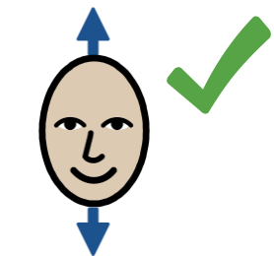 |  | NO  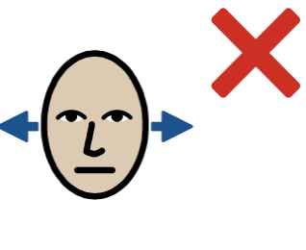
 | The University asks [trainee name] to record her/his work using videos.  This is so that he/she can look at how she/he is doing his/her work and make it even better. | I understand
 |  | YES | NO
 | Sometimes [trainee name] will look at the videos with his/her supervisor. A supervisor helps [trainee name] to learn. | I understand
 |  | YES | NO
 | Sometimes [trainee name] will look at the videos with a small group of other people on the University course and his/her supervisor.  This is to help everyone learn and get even better. | I understand
 |  | YES | NO

   | The University asks [trainee name] to record his/her work so that they can assess him/her.  The University wants to assess [trainee name] to make sure [trainee name] is doing well and can get even better at what they do. | I understand
 |  | YES | NO
 | The University wants [trainee name] to write about him/her work in a report, so that the University can assess him/her.  Your name will not be on the report. No-one will know who you are when they read the report.  The report is not stored with any recordings of you. | I understand
 |  | YES | NO
 | Recordings will be password protected to keep them safe.  No-one who sees the recordings can talk about them to people outside the university. | I understand
 |  | YES | NO
 | Recordings are always deleted (thrown away) after 6 years  You can ask for the recordings to be deleted at any time if you want to. | I understand
 |  | YES | NO
 | You can change your mind at any time.  Nothing will change about your treatment if you change your mind. | I understand
 |  | YES | NO

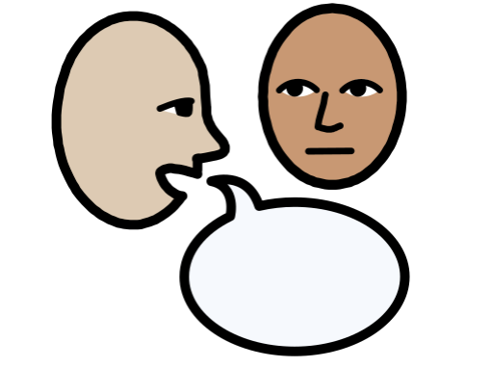 | If you change your mind, tell your therapist | I understand
 |  | YES | NO

Yes, I agree  I do not agree  to being:

    Taped (Audio) |  | Videoed |  |   Written About
YES | NO | YES | NO | YES | NO

When you sign this you are consenting (agreeing) to us collecting your information where you have indicated YES



Your Name (Signature): ………………………………………….. Date: …………………………

Or

I, as the appointed relative/carer, agree to this on behalf of: ………………………..

Name: ……………………………………………

Signature: …………………………………………. Date: …………………………

Signed: Trainee: _________________________________ Date: ____________

This is for [trainee name] to fill in:

Therapist Statement
“I certify that I have conducted this clinical work in line with appropriate professional practice guidelines, Codes of Ethics [e.g. BABCP Standards of Conduct, Performance and Ethics] and workplace Policies, which have been strictly adhered to in terms of making the recording and seeking permission for its use. This signed consent form will accompany the recording or case report.”

Signed: ....................................................................................
Therapist Name: ............................................................................. Date: ..............................

