Marking Criteria

ASD/ LD Module 3 Competency Recording C

Cognitive and/or behavioural intervention

Criteria based on CBTS‐CYP Stallard (2021)

PROCESS ‐ PRECISE

**1 Partnership working – collaboration and learning together**

Establishes a collaborative and respectful partnership with the child/young person (and, as appropriate, their parents/carers) in which they are actively engaged in working towards a set of joint goals and targets. This may be evidenced by:

* eliciting the child/young person’s and parents/carers’ understanding and

views

* encouraging and inviting the child/young person to participate in

discussions, option appraisal, and decision making

* involving the child/young person and parent/carer in goal and target

setting, intervention planning, home assignments, and experiments

* encouraging the child/young person to provide open and honest feedback

about sessions

**2 Right developmental level – pitch, methods, family involvement**

Engages with the child/young person and family at a level and in a manner

that is consistent with their developmental level and understanding. This may be evidenced by:

* ensuring an optimal balance between cognitive and behavioural

techniques

* using simple, clear, jargon‐free language that is respectful and not

patronising

* appropriately using a variety of verbal (direct and indirect approaches)

and non‐verbal techniques

* appropriately involving parents/carers/others in sessions.

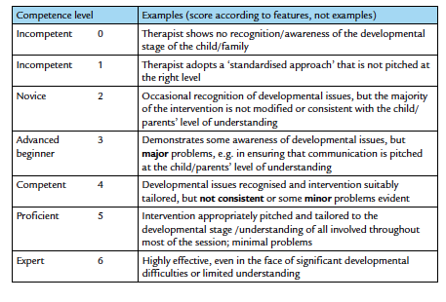

**3 Empathy – genuine, warm, understanding**

Empathises with the child/young person and their carers/family through the development of a genuine, warm, and respectful relationship. This may be evidenced by:

* conveying interest and concern through use of specific skills such as active
* listening, reflection, and summaries
* acknowledging and appropriately responding to the child/young person’s

and carers/parents’ verbal and non‐verbal expressions and emotional

responses such as distress, excitement, or anxiety

* demonstrating an open, respectful, non‐judgemental, caring approach
* appropriately empathising with carers/parents about their own difficulties

and the impact of these on their ability to help their child

**4 Creative – verbal and non‐verbal techniques**

Adapts the ideas and concepts of CBT to facilitate the understanding of and engagement in therapy of the child/young person and their parents/ carers.

This may be evidenced by:

* tailoring and adapting concepts and methods of CBT around the interests

of the child/young person

* using an appropriate range of verbal and non‐verbal methods to facilitate

understanding and engagement

* creatively using a range of methods, e.g. talking, drawing, questionnaires,

metaphor, role play, puppets, etc., to convey ideas and concepts

* utilising the preferred media of the child/young person, e.g. verbal, visual,

computer

**5 Investigation – reflection and insight**

Adopts an open and curious stance that facilitates guided discovery and

reflection. This may be evidenced by:

* creating a process of collaborative inquiry in which the child/young
* person’s and/or parents/carers’ cognitions, beliefs, and assumptions are

subject to objective evaluation

* involving the child/young person in the design of experiments
* helping the child/young person and/or parents/carers to consider

alternative explanations about events

* encouraging the child/young person and/or parent/carer to reflect on the

outcomes of experiments

**6 Self‐efficacy – build on strengths and ideas**

Adopts an empowering and enabling approach in which self‐efficacy and positive attempts at change are promoted. This may be evidenced by:

* identifying and highlighting the child/young person’s and/or parents/

carers’ strengths and personal resources

* helping the child/young person and/or parents/carers to identify skills

and strategies that have shown some past success

* developing and shaping the child/young person’s and/or parents/carers’

ideas and coping strategies

* praising and reinforcing the child/young person’s and/or parents/carers’ use of new skills

**7 Enjoyable – fun and engaging**

Makes therapy sessions appropriately interesting and engaging. This may be evidenced by:

* using an appropriate mix of materials, activities, humour
* maintaining an appropriate balance between task and non‐task

(relationship strengthening) activities

* attending to the child/young person’s interests and appropriately

incorporating these into the intervention

* presenting as positive and hopeful

SKILLS… the ABCs…

**B Behavioural techniques – awareness, triggers, techniques of change**

Demonstrates appropriate use of a variety of behavioural techniques to

facilitate therapeutic change. This may be evidenced by:

* using behavioural techniques such as developing hierarchies, graded

exposure, proactive and reactive strategies

* using behavioural techniques such as activity rescheduling and

behavioural activation

* providing a clear rationale for using behavioural strategies
* identifying and implementing reward and contingency plans modelling, use of role play, structured problem‐solving approaches, or

skills training

**C Cognitive – awareness, identification, challenge, cognitive reframe**

Demonstrates appropriate use of a variety of cognitive techniques to

facilitate therapeutic change. This may be evidenced by:

* facilitating cognitive awareness and the use of appropriate techniques

such as thought records and bubbles

* identification of cognitions that are functional/dysfunctional and helpful/

unhelpful

* identifying important dysfunctional cognitions and common cognitive

biases, ‘thinking traps’

* facilitating the generation of alternative balanced cognitions by thought

challenging and alternative perspective taking

* facilitating continuum work and use of rating scales
* promoting mindfulness, acceptance, and compassion

**D Discovery – strengths, new information and meanings**

Appropriately uses a variety of methods to facilitate self‐discovery and

understanding.

This may be evidenced by:

* facilitating self‐discovery and reflection through use of the Socratic

dialogue

* facilitating self‐discovery through alternative perspective taking and

attending to new information

* valuating beliefs, assumptions, and cognitions through behavioural

experiments or prediction testing

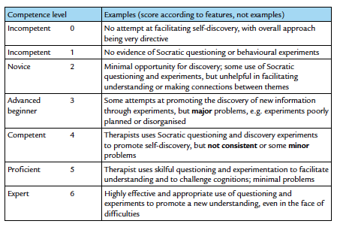

**E Emotional – awareness, identification, management**

Appropriately uses a variety of emotional techniques to facilitate therapeutic change. This may be evidenced by:

* developing emotional literacy by facilitating the identification of a range

of emotions

* helping to distinguish between different emotions and identifying key

bodily signals

* developing emotional management skills such as relaxation, guided

imagery, controlled breathing, and calming activities

* developing emotional management skills such as physical activity, letting

the feelings go, emotional metaphors, emotive imagery, and change the

feeling

* developing emotional management skills such as self‐soothing, mind

games, and mindfulness

**G General skills – session planning and organisation**

Sessions are well prepared and conducted in a calm and organised way. This may be evidenced by:

* preparing and bringing the necessary materials and equipment to the

meeting

* managing the child/young person’s behaviour during sessions
* ensuring that sessions have an agenda and clear goals and are

appropriately structured

* ensuring good timekeeping so that all tasks are completed
* ensuring that sessions are appropriately paced, flexible, and responsive to

the needs of the child/young person

* preparing for endings and relapse prevention

**H Home assignments – transfer knowledge and skills to everyday life**

Uses home assignments to gather data and transfer skills between clinical

sessions and everyday life. This may be evidenced by:

* negotiating and agreeing assignment tasks
* ensuring assignments are meaningful and clearly related to the

formulation and clinical session

* ensuring assignments are consistent with the young person’s

developmental level, interests, and ability

* agreeing realistic, achievable, and safe assignments
* referring to goals when planning home assignments and to rating scales

when reviewing progress

* encouraging review and reflection of learning

